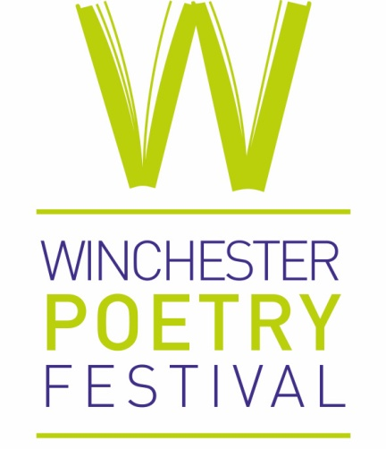

Winchester Poetry Festival

Call for Digital Production/Conferencing Services

- SUMMARY

Winchester Poetry Festival (Registered Charity No: 1150997) is seeking to commission digital production/conferencing services from either a freelance digital producer or a digital production company to manage a series of digital events via Zoom (or similar as required) for its 2021 Festival. This year, the Festival will take place over 6 weekends between May and what we hope will be a live culmination festival weekend in October 2021. An indicative schedule of events and production requirements is attached (nb tbc).

The appointed person/company will be expected to advise on solutions and to manage the digital delivery of events across a six-month period to makes these smooth, efficient, and professionally produced.

Winchester Poetry Festival (WPF) has always ensured high quality in its work and presentations and wishes to ensure that this continues during the delivery of its programme online.

- Introduction and Background to this year’s Festival

Established in 2013 Winchester Poetry Festival’s mission is to bring poetry and poets to new audiences and to introduce audiences to new and diverse poets. We achieve this through a biennial festival, annual poetry prize, an education and outreach programme and one-off events and celebrations. We are international in outlook and rooted in our community. https://www.winchesterpoetryfestival.org/

Traditionally, WPF delivers its Festival over a long weekend in October. The 2020 festival was planned for October 2020 but had to be postponed due to Covid Restrictions.

While it had been hoped to return to a fully live festival for October 2021, continuing uncertainly has led to WPF exploring different and innovative ways of presenting its festival programme. We have decided therefore to ‘stretch’ the festival across a 6-month period presenting a series of Festival ‘Shots’ (one-day events – with 3 or so sessions per day - which capture the essence and activity of the festival) from May to October.

- THE BRIEF

Winchester Poetry Festival wishes to commission digital production services from either a freelance digital producer(s) or a digital production company to manage a series of digital events via Zoom (or similar) for its 2021 Festival which will take place over 6 weekends from May, culminating in what we hope will be a live festival weekend in October 2021. An indicative schedule of events and production requirements is attached (nb tbc).

Currently there are plans for 30 events (a mix including Workshops, Webinars, Talks, Readings, Discussions, Prizegiving Ceremony) across this 6-month period – see attached schedule. These will take place on the following dates:

- 8 May
- 12 June
- 10 July
- 14 August
- 12 September
- 8/9/10 October (live events if/as feasible)

Some events will be straightforward Zoom meeting-type sessions - such as workshops and reading groups - while others will be created in different ways and need varying levels of technical knowledge and support including the application of e.g. ZOOM breakout rooms for small discussion groups, presentation slides, embedded sound, recording, survey options, and Q and A Boards. One or two events may need to run as a Zoom Webinar, while others might be pre-filmed and need to be broadcast. It is also possible that for our planned live events in October, we may wish to live stream this, and/or to have live presentation from, e.g. the United States.

Winchester Poetry Festival team does not have the level of expertise required to run these ‘webinar’ type events or anything outside the ordinary such as live-streamed events, You-Tube broadcasts, events including pre-filmed content etc.

WPF therefore is looking for a creative and flexible approach with a commitment to excellence. The precise delivery details will be confirmed as the programme is finalised. A detailed timetable for our series of Festival Events (NB still subject to final confirmation) related to this brief is attached to the Brief is attached.

4) TIMELINE
- Responses to this brief should be submitted by email to Madelaine Smith (hello@winchesterpoetryfestival.org ) by 18:00 hours on FRIDAY 7th April 2021
- Interviews (if/as required): By Wednesday 14th April 2021
- Consultant Services selected and work begins from Thursday 15th April 2021
- Planning meeting with WPF: w/c 19th April 2021 (via Zoom)
- Work to be completed by 12th October 2021

5) FEE
An amount of up to £3000 (+ VAT if relevant) is available for this work. The precise fee however, will be negotiated and agreed with the selected provider once the programme is finalised, the requirement for provider services clarified, and the detail agreed.

6) MANAGEMENT AND REPORTING ARRANGEMENTS
The appointed consultant will be contracted by Winchester Poetry Festival. They will be expected to work closely with Festival Manager, Madelaine Smith, and Artistic Director, Sasha Dugdale.

7) HOW TO SUBMIT A RESPONSE
The successful appointee will be able to demonstrate the following:
- Excellent experience of managing and delivering online digital production/conferencing services
- Strong interpersonal skills to work effectively with WPF, both face to face and via telephone and video conference
- Ability to ensure a professional approach resulting in a high quality set of experiences for audiences and presenters
- Strong organisational, administrative and project management skills
- Availability to deliver the project in line with the requirements outlined in the brief

In addition, you are asked to:
- include assurance (evidence such as previous reports/previous work etc) to the selection panel that you/your company is fit, proper and adequately insured to undertake such work.
- In addition, you are required to provide two referees that have previously been customers for projects of a similar size and complexity.
- Details of your professional indemnity and public liability insurance.

To discuss the brief, or for more information, please contact hello@winchesterpoetryfestival.org

If you are interested in this opportunity, please email Madelaine Smith at hello@winchesterpoetryfestival.org by 18:00 hours on FRIDAY 7th April 2021 with:

- A summary of your proposed approach to the work (max 500 words)
- A curriculum vitae setting out relevant skills and experience of all those to engaged with this brief
- The contact details of two recent clients for similar assignments who can be approached for a reference.

Please note that Winchester Poetry Festival will be assessing all submissions received against the following criteria:
- Understanding of the brief and key objectives
- Proposed approach
- Experience and expertise
- Value for money (WPF is a registered charity and value of money is an important consideration

Do note that WPF is not bound to accept the lowest cost, or indeed any proposal received.

CONFIDENTIALITY
The appointed organisation or individual is required to maintain the confidentiality of all propriety or privileged information which they may be party to in the course of the contract, and they are expected to work on behalf of Winchester Poetry Festival.

Thank you very much for your interest.

Winchester Poetry Festival has an active Equal Opportunities policy. No job or role applicant or employee shall receive less favourable, or more favourable, treatment on the grounds of age, care of dependants, disability, gender, gender reassignment, marriage & civil partnership, pregnancy & maternity, race, religion & belief, sexual orientation or socio-economic background & status.

Date: 17th March 2021

